**PHASE 5 SUBMISSIONS : Consolidation of Phase 3 and 4 submissions, final summary:**

**1. Visual Recognition Service in IBM Cloud:**

IBM offers a Visual Recognition service as part of its cloud platform, which enables users to build custom image recognition models with ease. The service leverages deep learning and computer vision technologies to classify images and detect objects within them. Users can train the model to recognize specific objects, concepts, or visual patterns relevant to their applications. The service is often used in industries such as retail, healthcare, and manufacturing for tasks like quality control, product recognition, and content moderation. It provides an accessible interface for training and deploying image recognition models without the need for extensive machine learning expertise, making it a valuable tool for businesses and developers looking to harness the power of visual recognition in their applications.

**2. Fashion MNIST Project on IBM Cloud:**

IBM Cloud can be used for a variety of machine learning projects, including those involving the Fashion MNIST dataset. In such a project, IBM Cloud's infrastructure and services can facilitate the development of image classification models tailored to fashion items. This may involve training deep learning models, like convolutional neural networks (CNNs), to recognize different clothing categories within the Fashion MNIST dataset. Researchers and developers can harness IBM Cloud's computational resources and machine learning capabilities to experiment with model architectures, fine-tune hyperparameters, and deploy the final model for real-world applications. By leveraging IBM Cloud, organizations can efficiently build and deploy image recognition solutions for fashion-related tasks, such as recommending clothing items or automating inventory management.

**DEVELOPMENT PART 1**  
Since the Visual Recognition Service is not available (deprecated), already available resources (youtube videos) were used to grab screenshots of the process flow.

**STEP 1:** After IBM (365 days free trial)was created, Visual Recognition service is added from the Catalog.

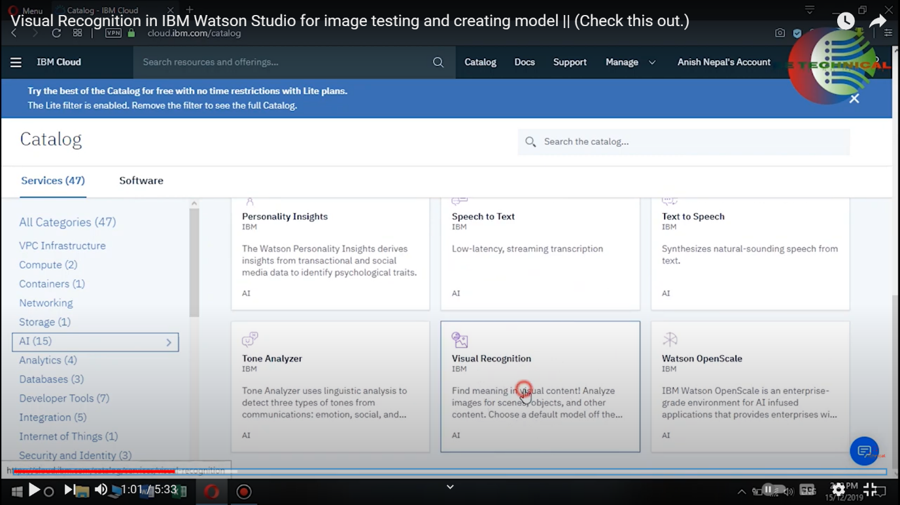

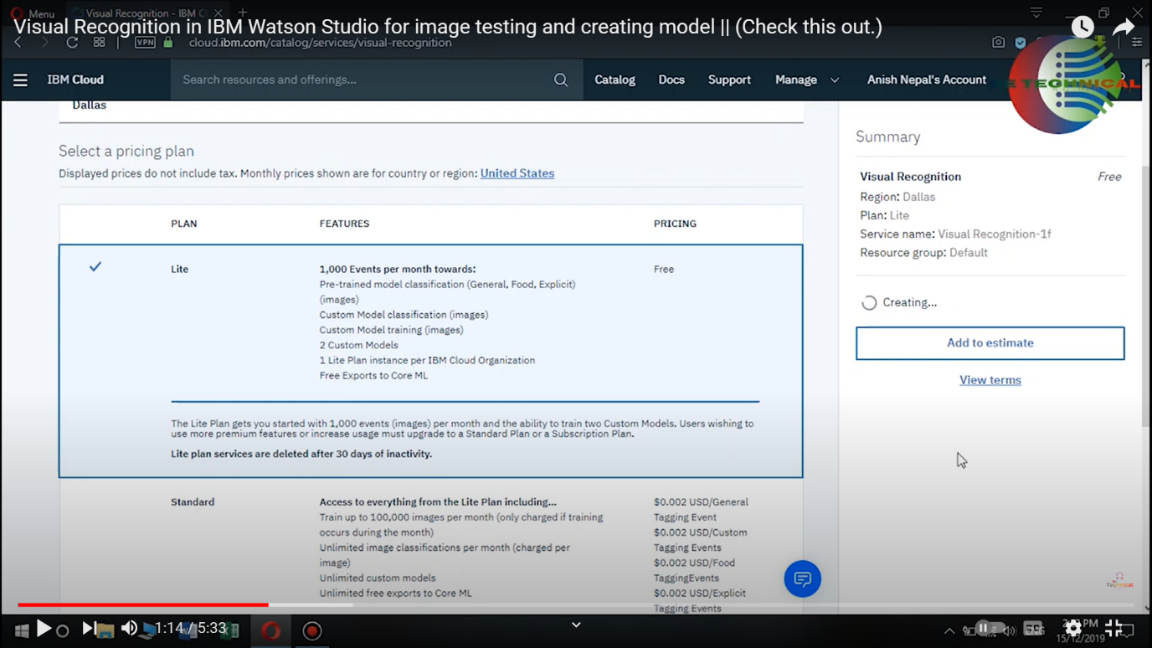

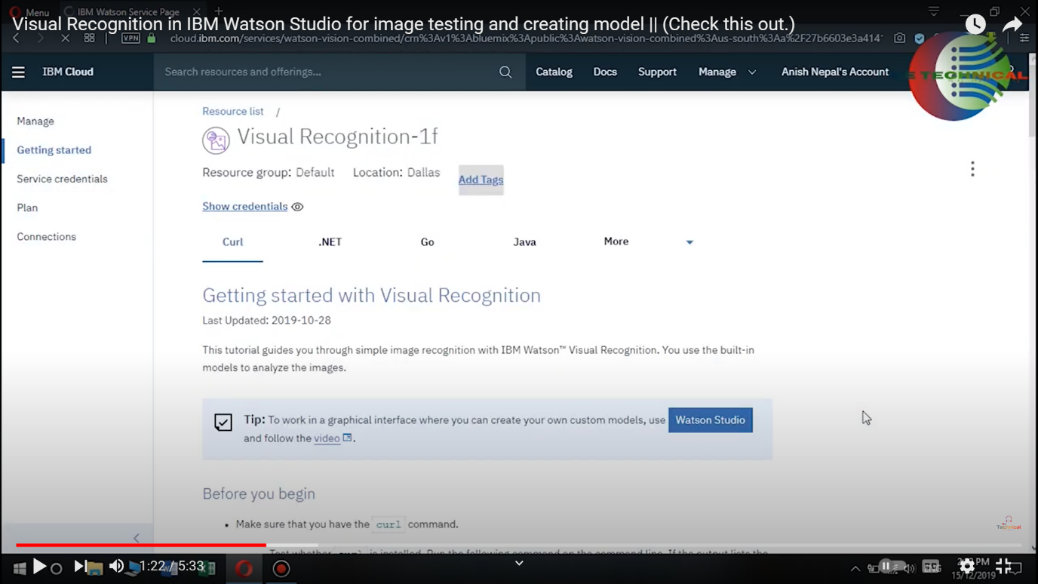

**STEP 2** : Building Image Classifying models

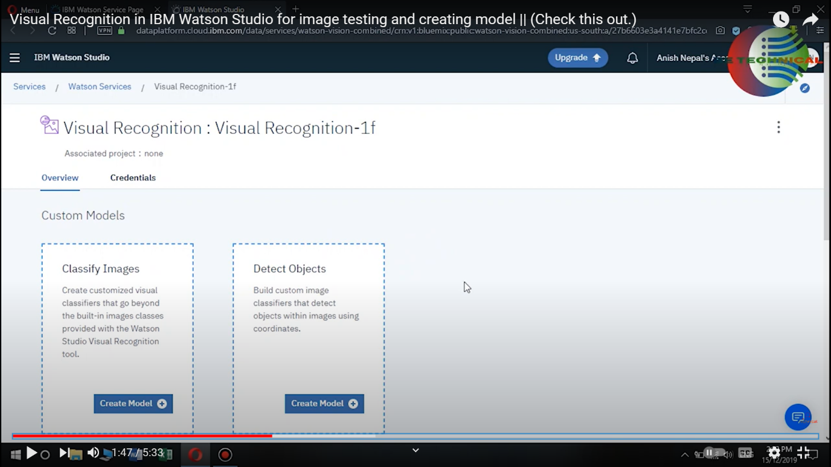

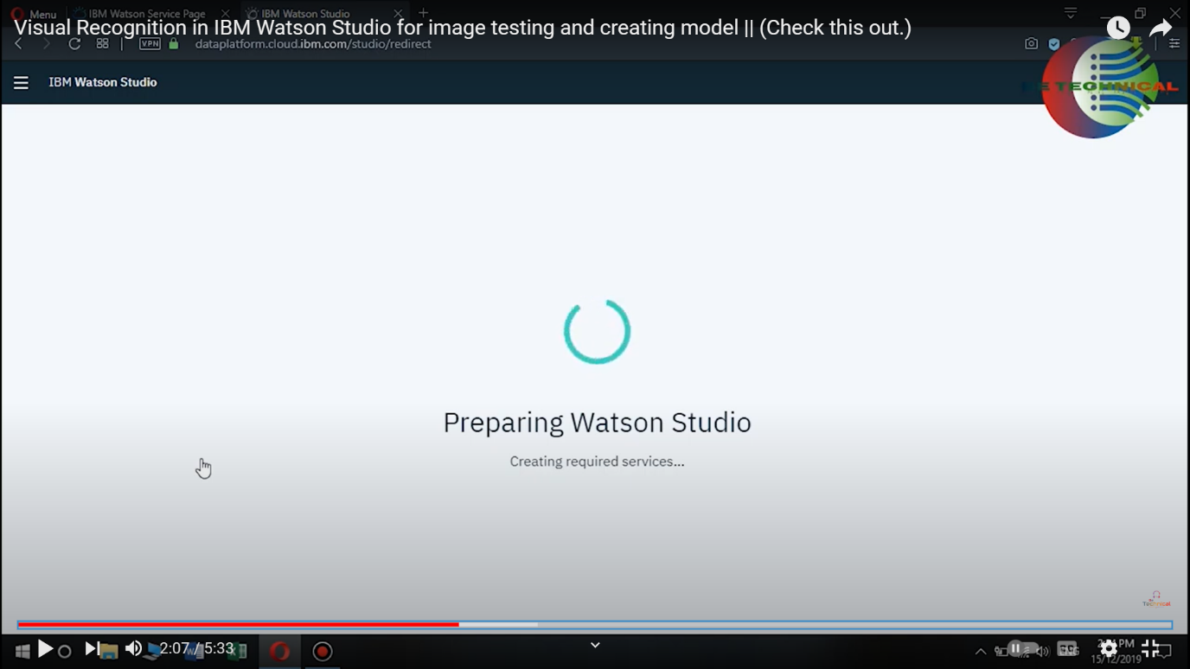

**STEP 3** : Create new project , add description.

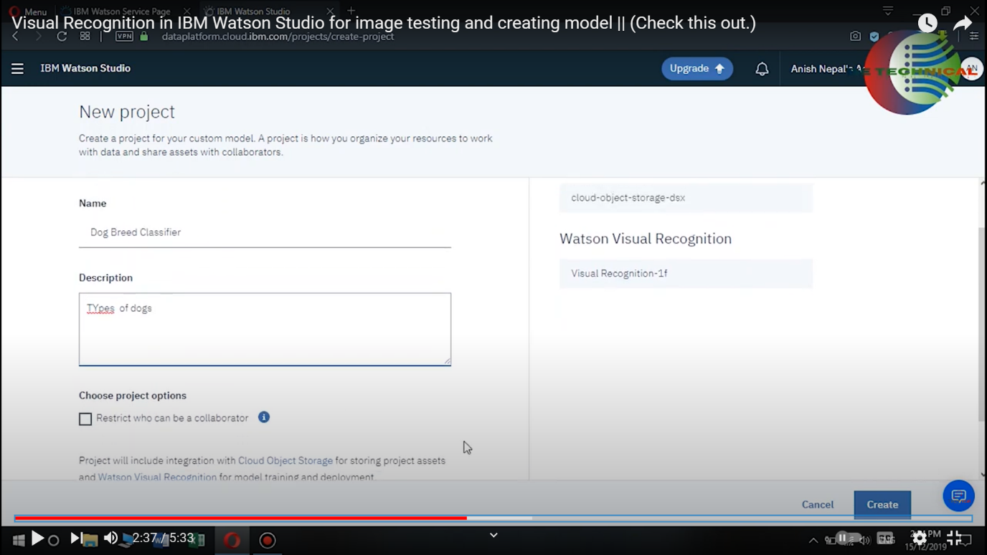

STEP 4 : Build Custom Models

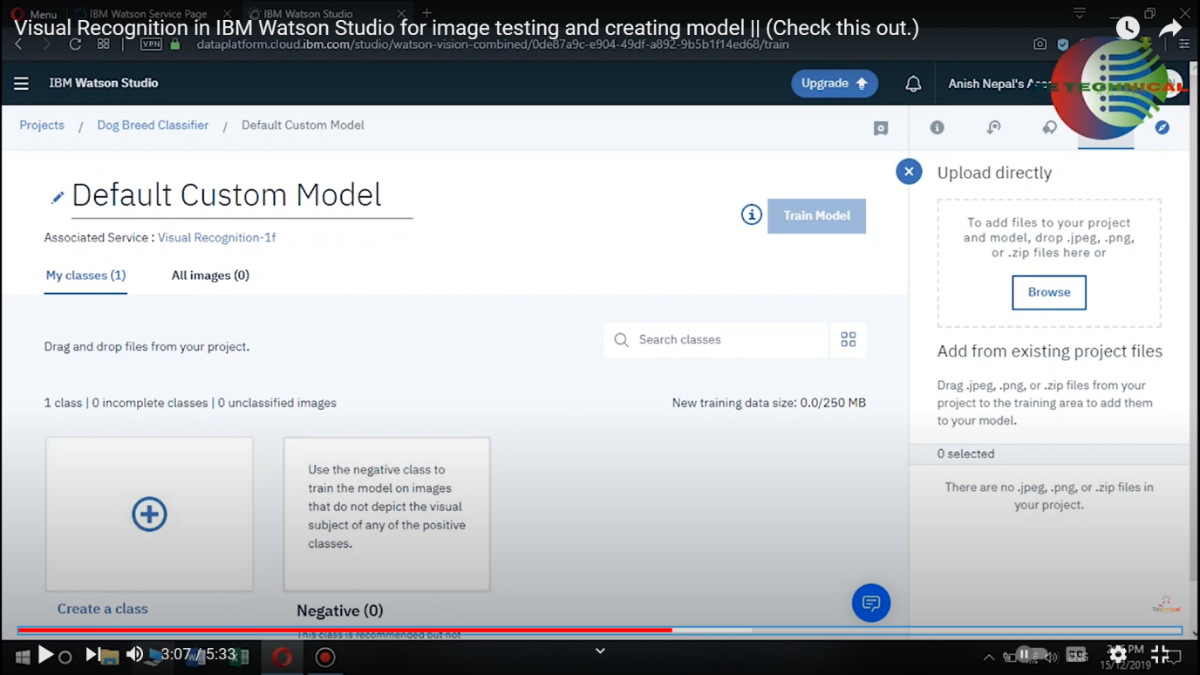

**STEP 5** : Upload training files dataset from device (custom).

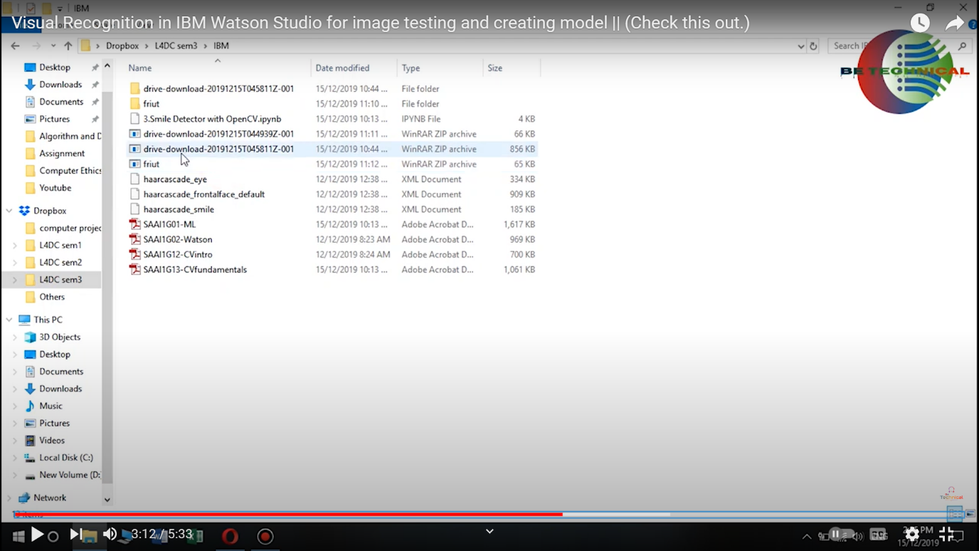

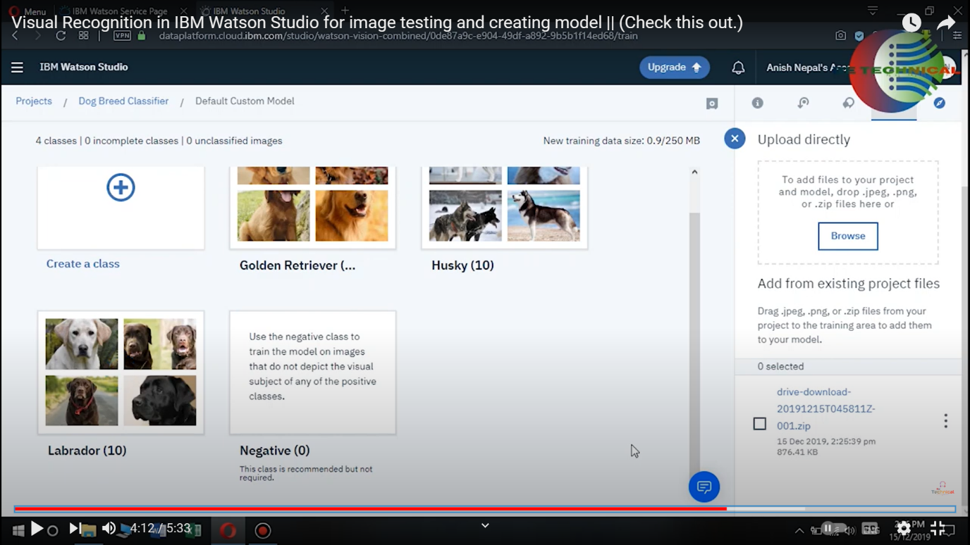

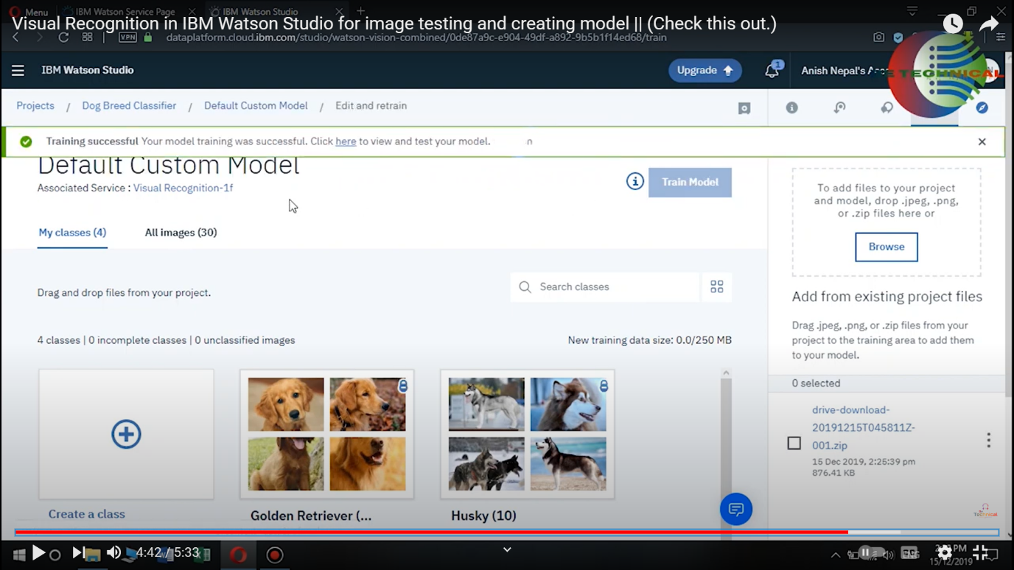

**STEP 6** : Default Custom model is built.

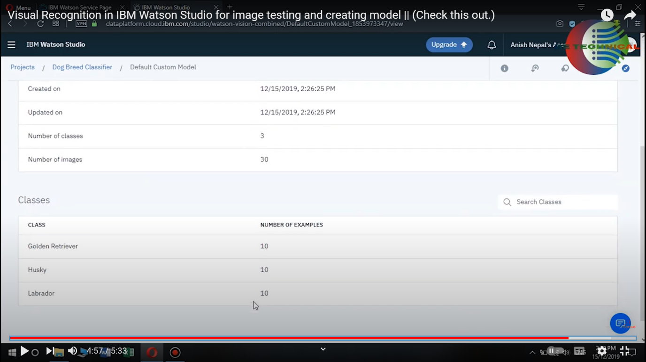

**STEP 7:** Few images are tested.

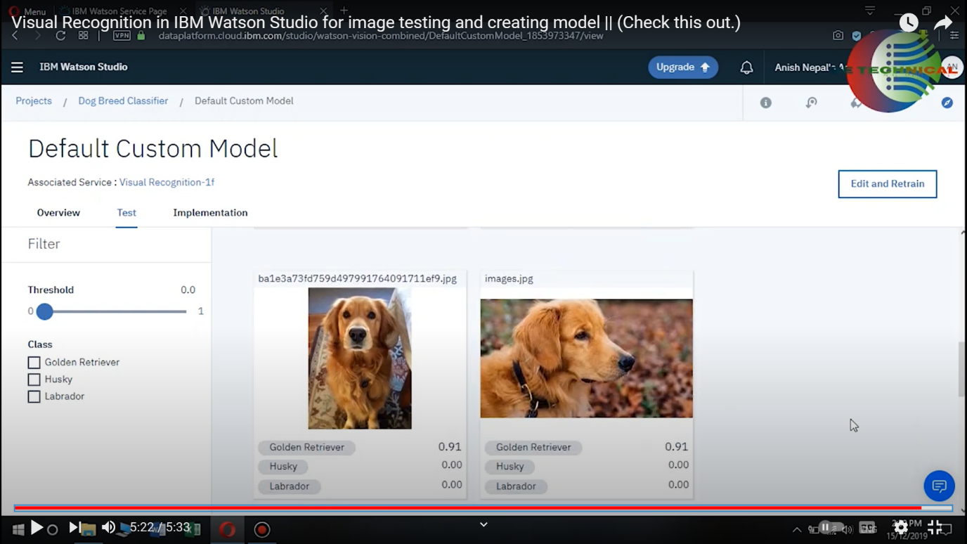

Dataset Description: Fashion MNIST is a dataset of grayscale images of clothing items, with a total of 10 different categories. Each category corresponds to a different type of clothing, such as T-shirts, dresses, sneakers, and more. There are 60,000 training images and 10,000 testing images, each of size 28x28 pixels.

Purpose: Fashion MNIST is often used as a replacement for the classic MNIST dataset of handwritten digits. It's a more challenging dataset because it involves classifying images of real-world objects with more visual complexity.

Machine Learning Projects: Organizations like IBM, as well as many other companies and researchers, may use the Fashion MNIST dataset for various machine learning and computer vision projects. Some common use cases include:

Image Classification: Building machine learning models to classify the images into one of the 10 categories.

Deep Learning: Using convolutional neural networks (CNNs) to achieve state-of-the-art performance on Fashion MNIST.

Transfer Learning: Adapting pre-trained models (e.g., from ImageNet) for the task of fashion item classification.

Benchmarking Algorithms: Comparing and evaluating different machine learning algorithms and models using this dataset.

Research and Education: Fashion MNIST is also used in educational contexts and research to teach and explore concepts related to image classification, deep learning, and computer vision.

Open Source Community: The dataset is readily available to the open-source community, making it accessible for researchers, students, and developers to experiment with and build upon.

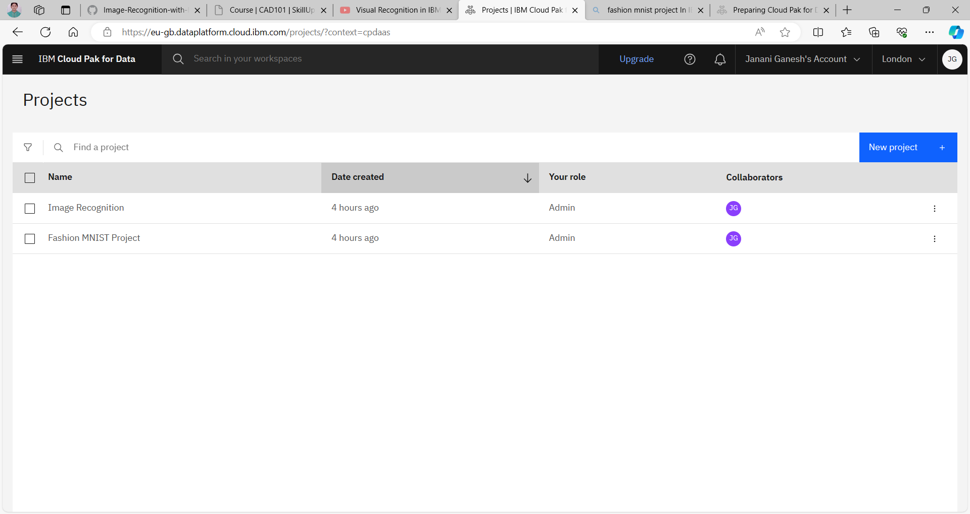

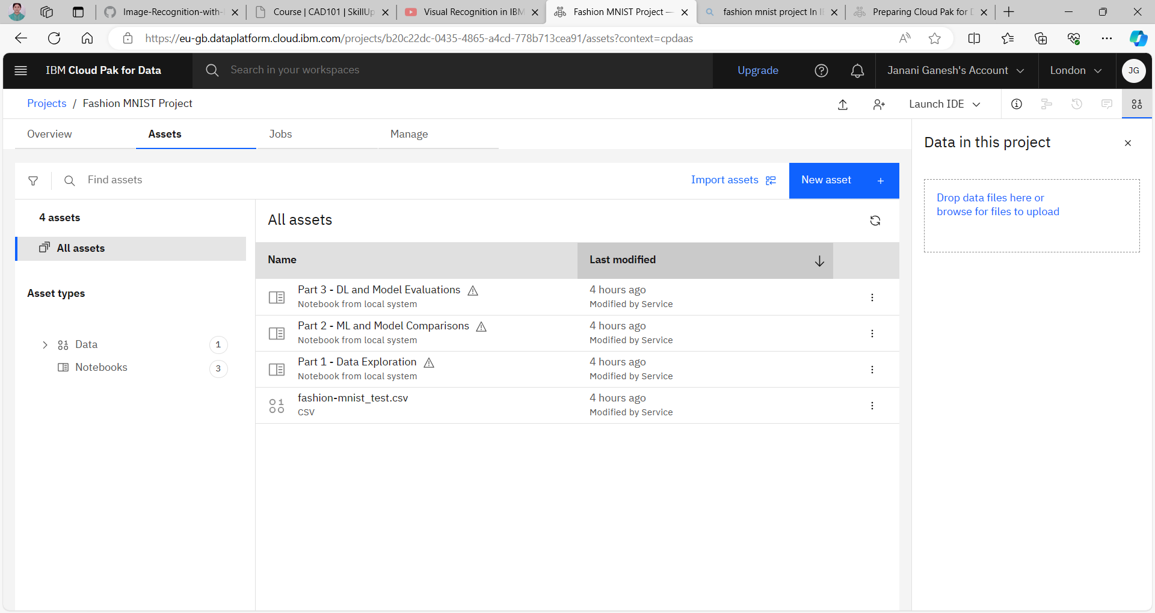

Part 1 : Data Exploration

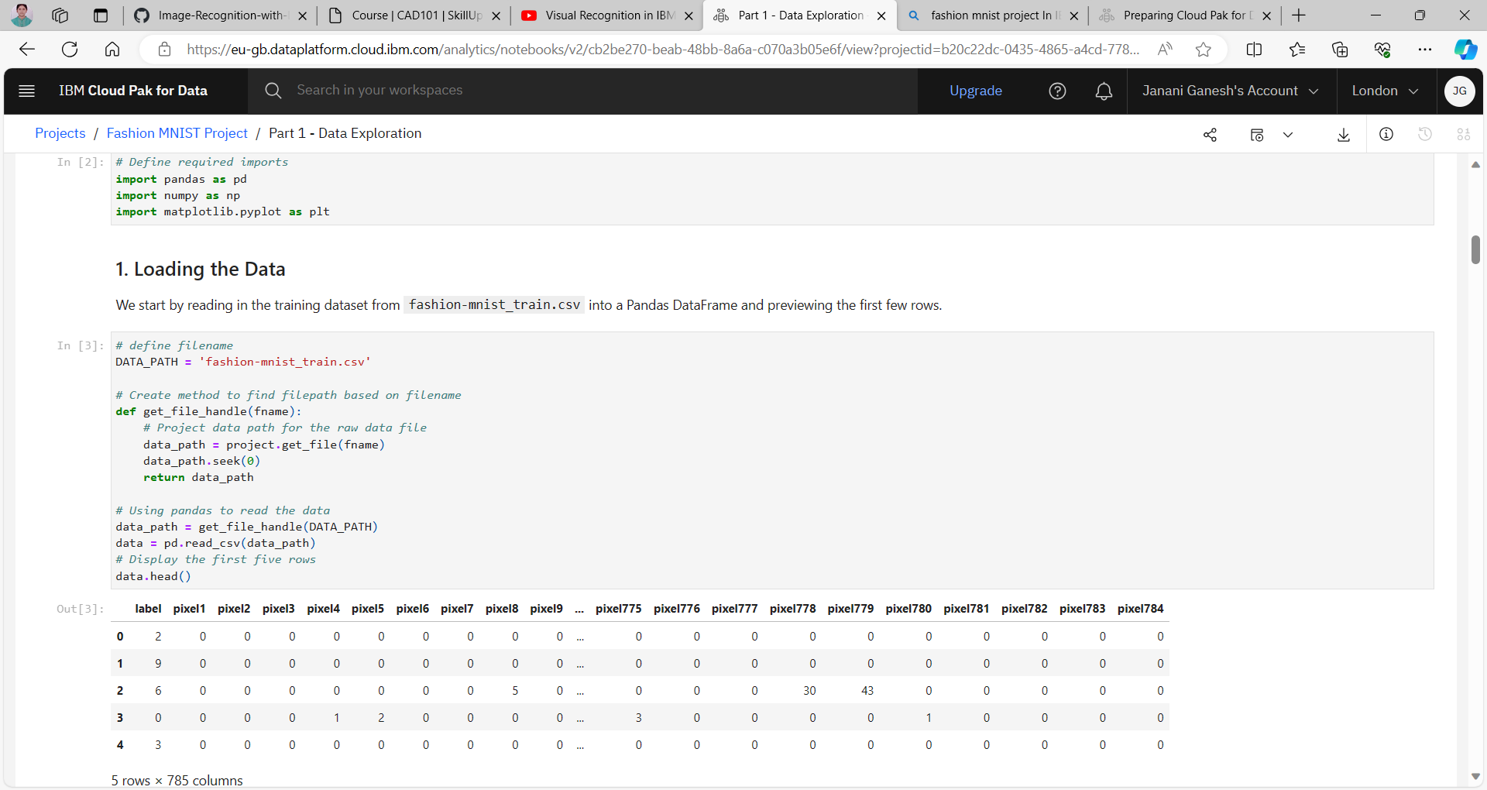

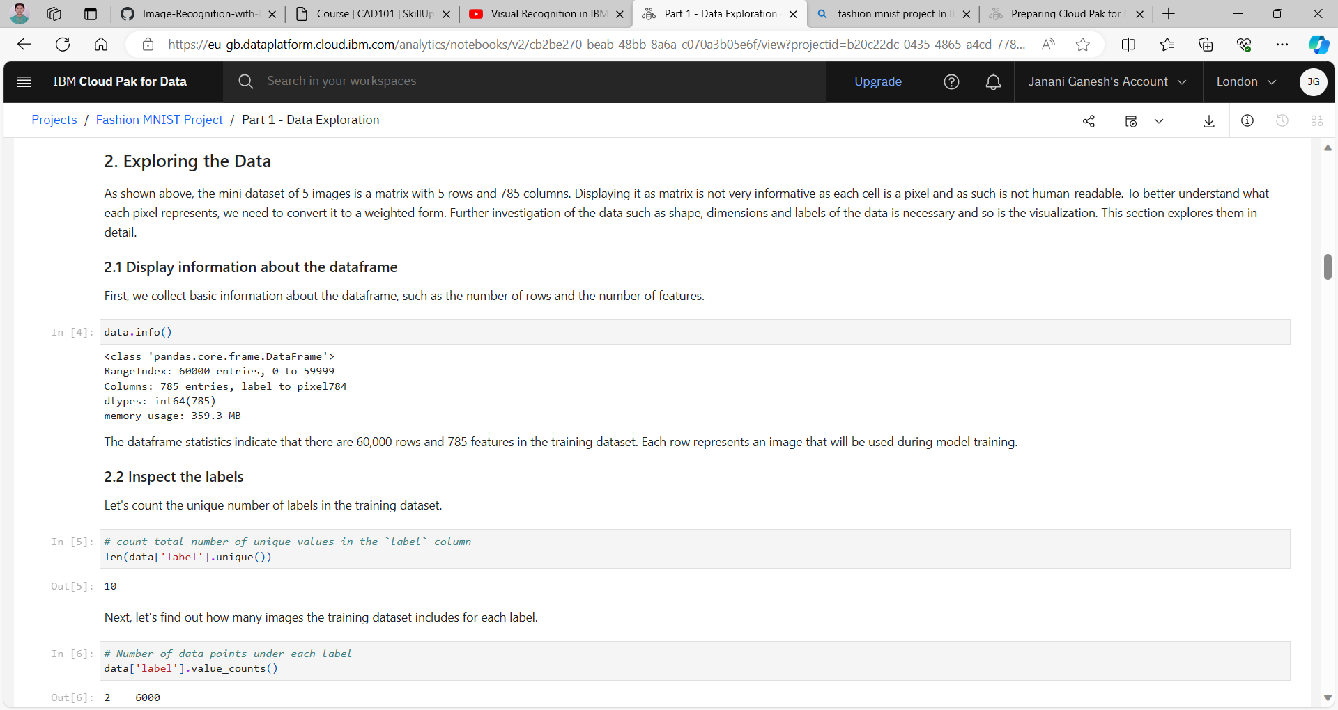

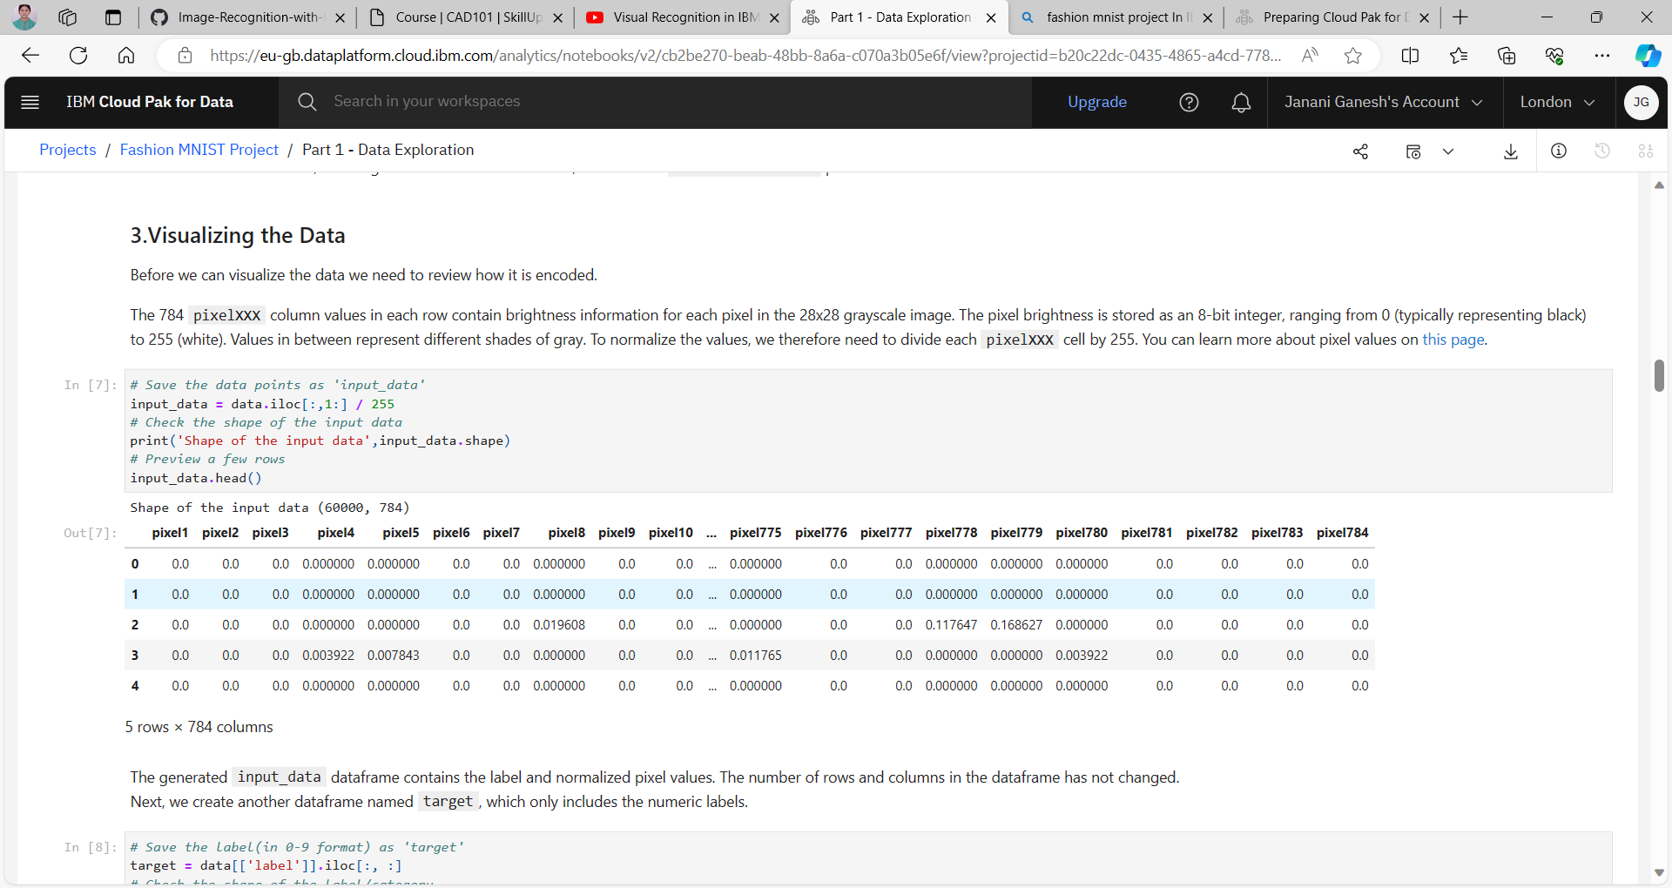

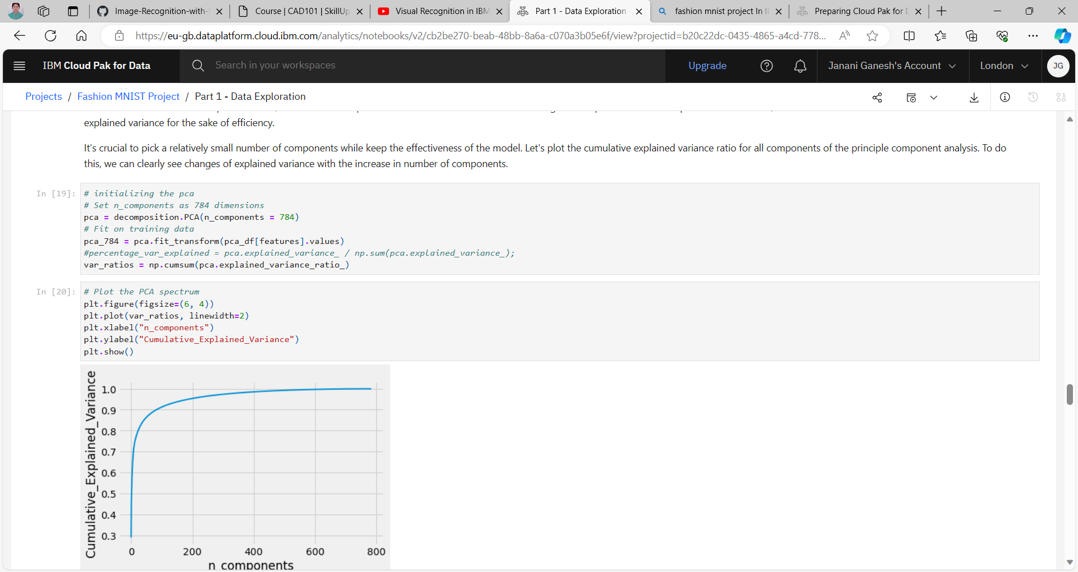

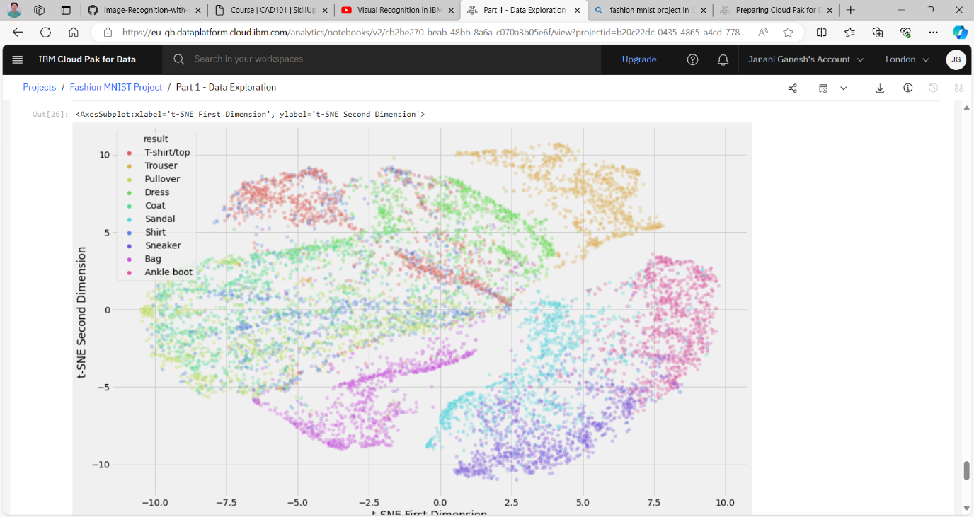

Part 2: ML and Model Comparisons

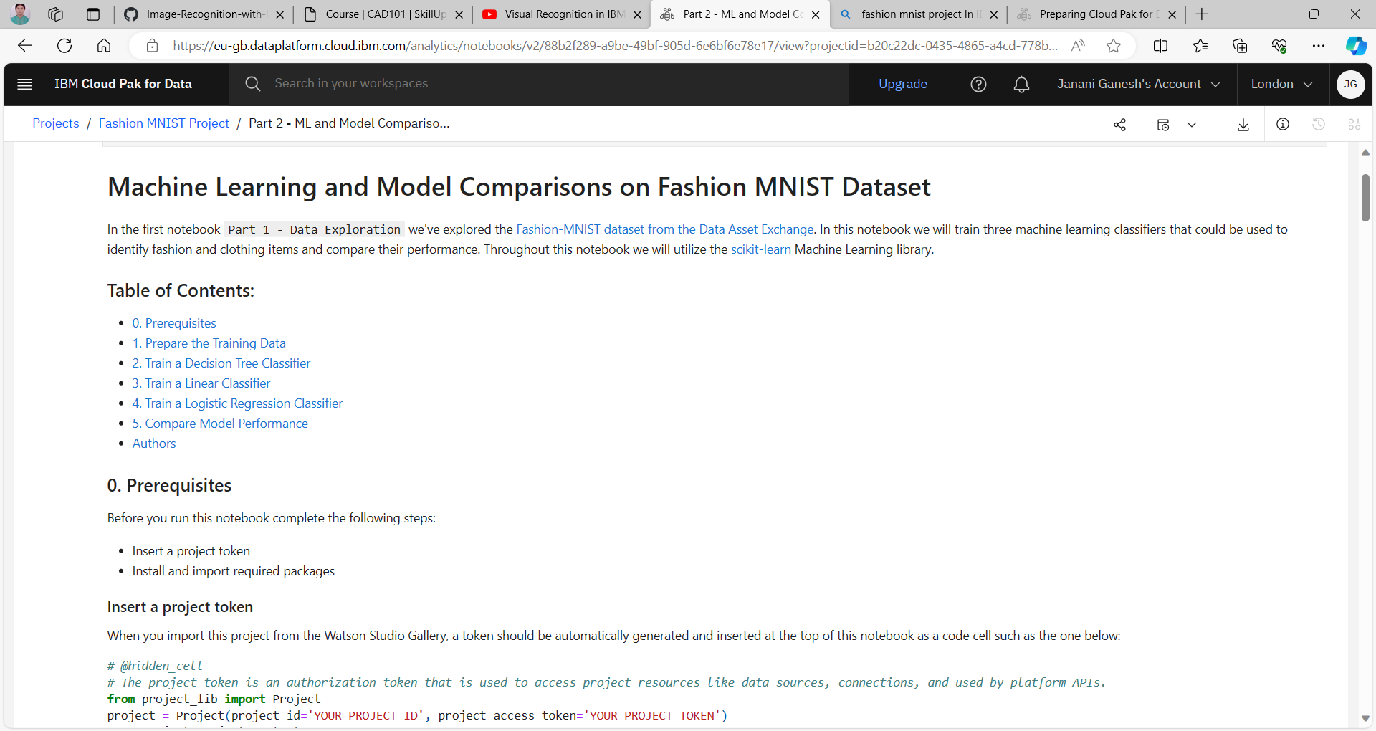

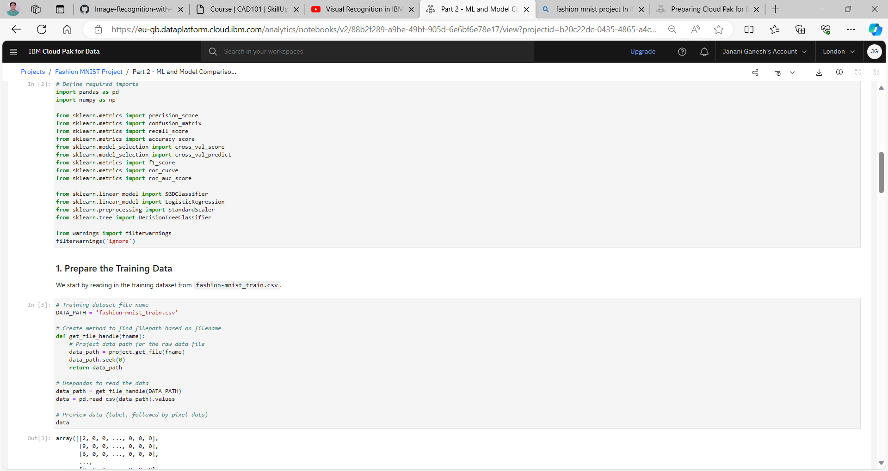

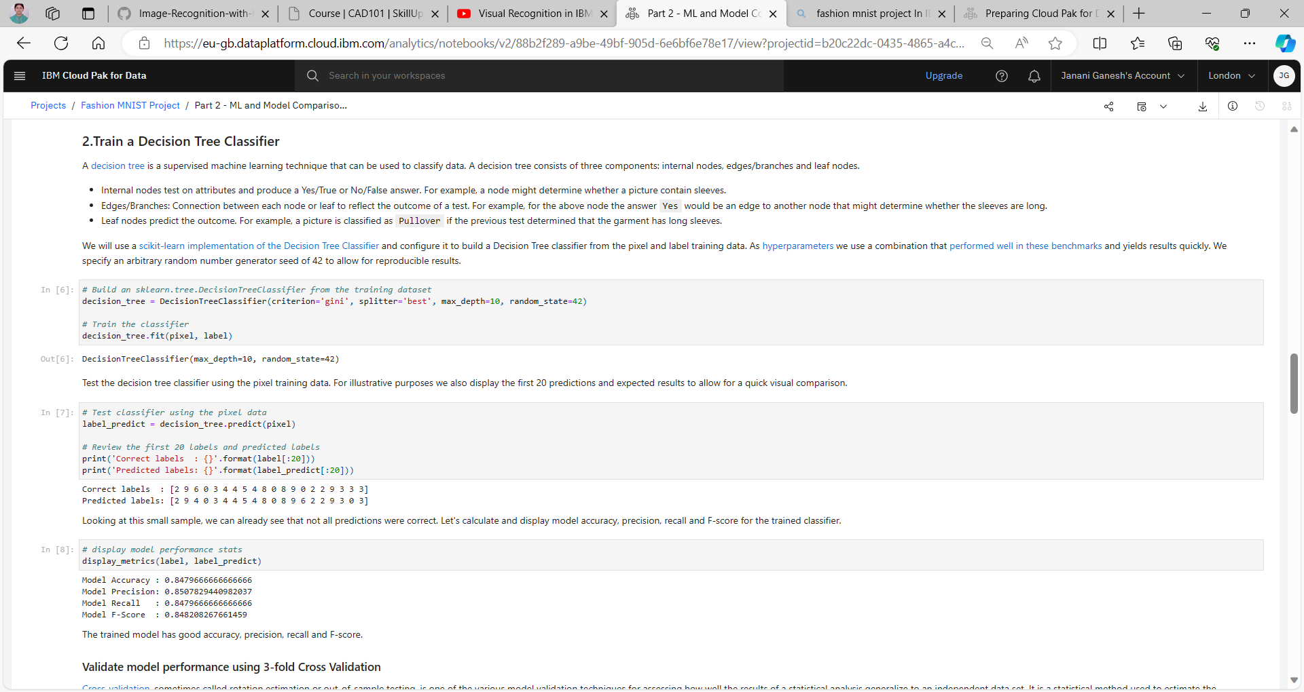

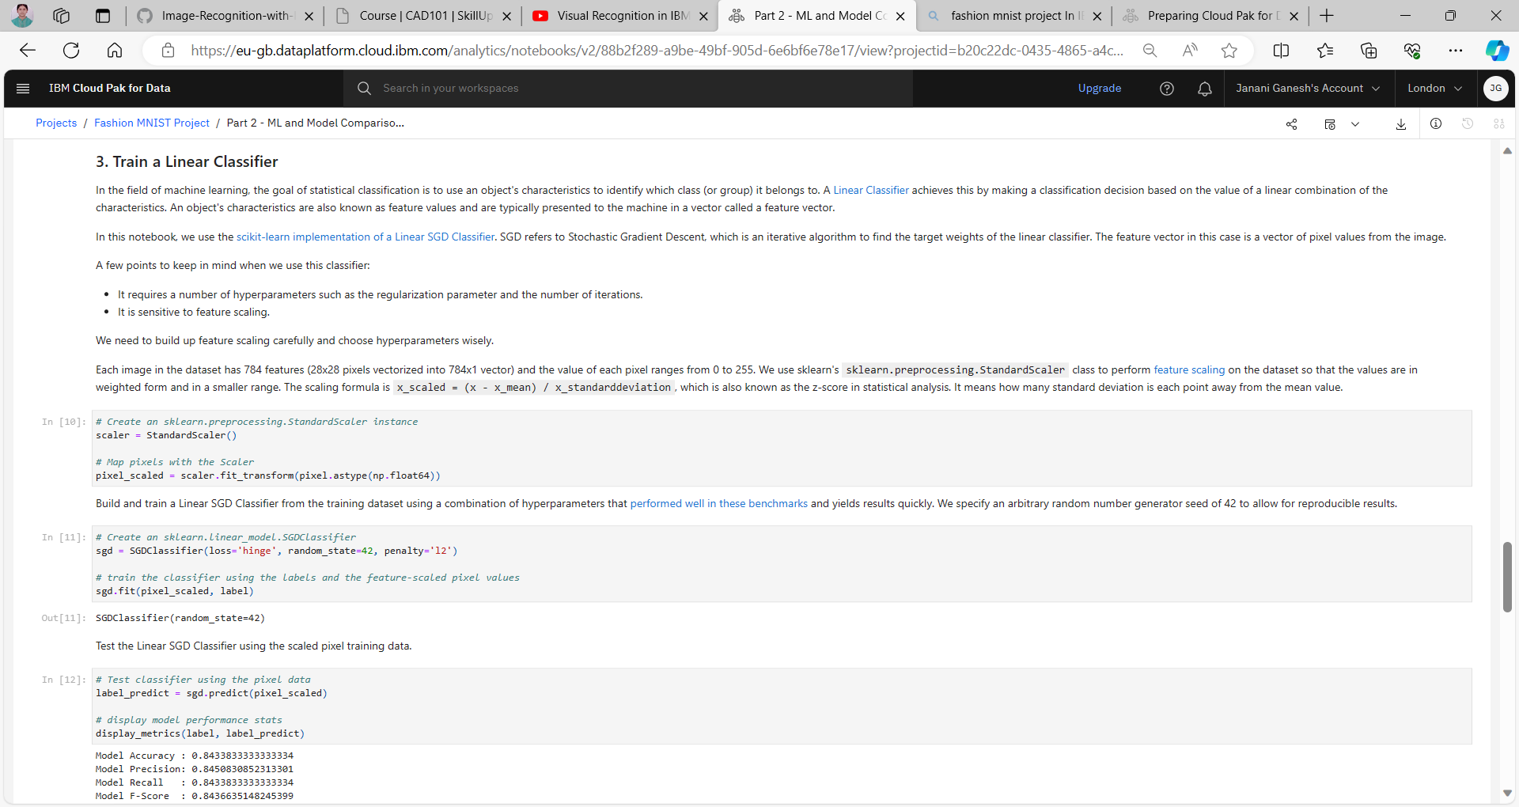

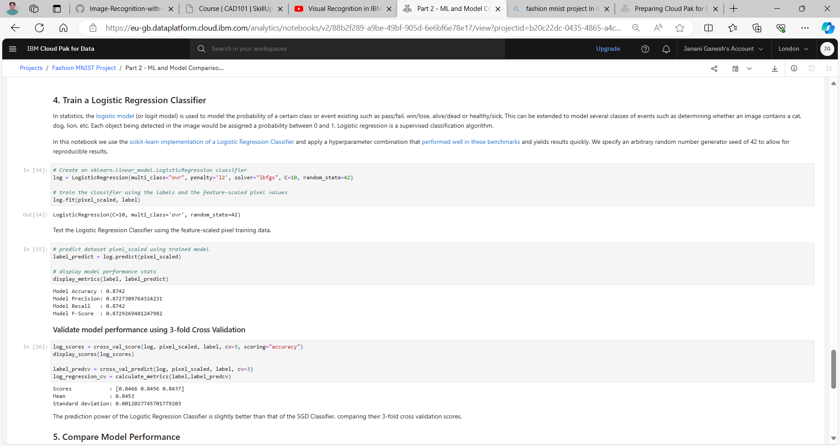

Part 3 : DL and Model Evaluations

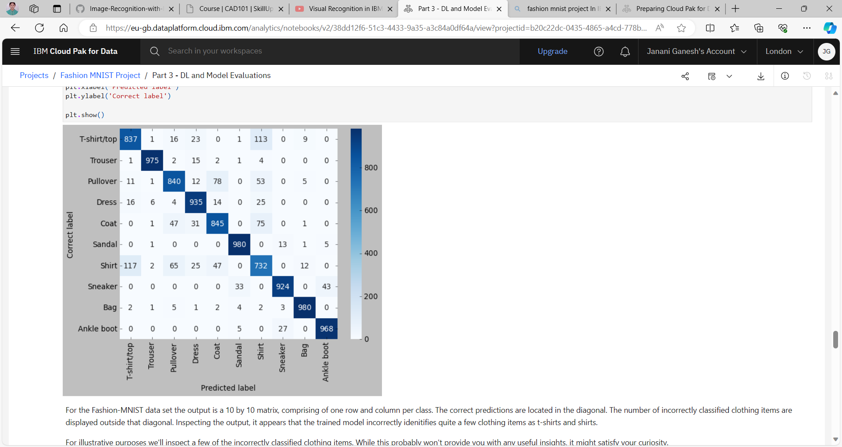

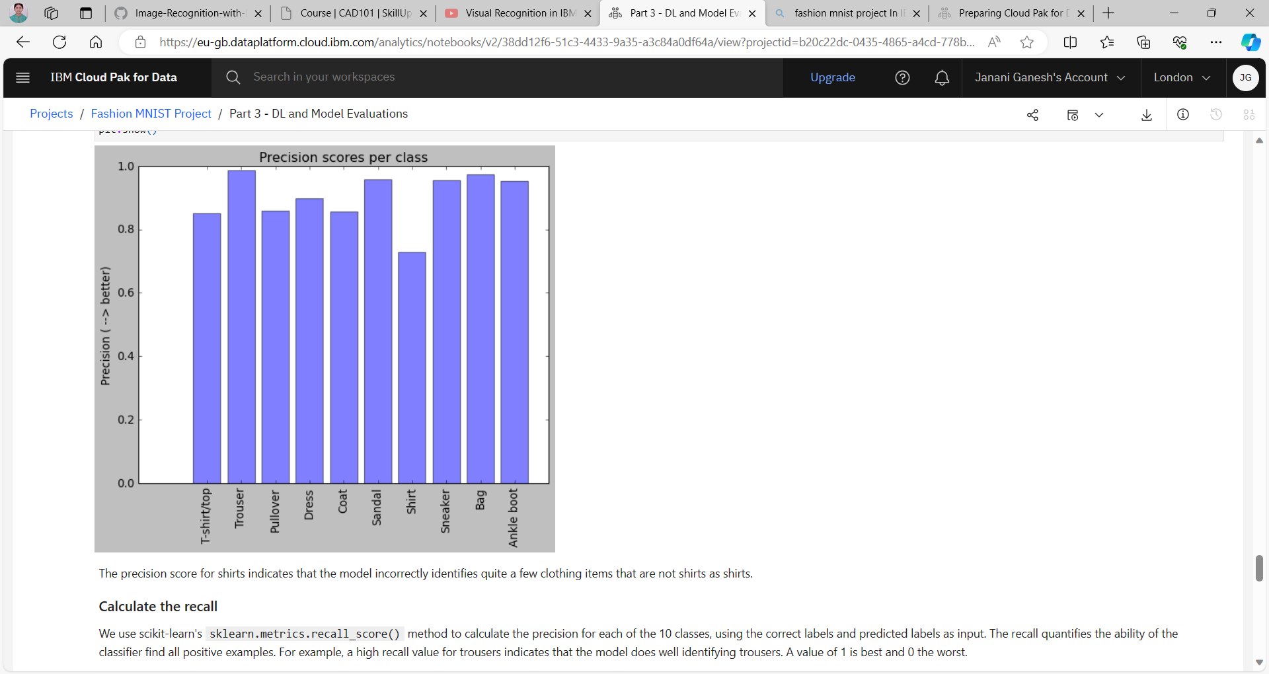

Thus we gained insights into the various Image Recognition concepts and services available in IBM cloud.